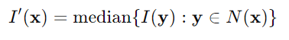

$I^\backslash prime\backslash left(X\backslash right)=median\{I\backslash left(y\backslash right):y∊ N(x)\}$ 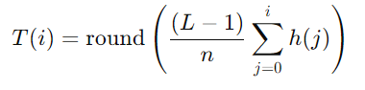

$T(i)=round\backslash left. \backslash left(\backslash frac\{(L-1)\}\{n\}\backslash sum_\{j=0\}^\{i\}\{h(j)\}\backslash right.\backslash right)$

$$(\backslash sum_\{j=0\}^\{i\}\{h(j))\}$$

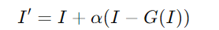

$$I' = I+α(I -G(I))$$

